Seigniorage and Monetary Policy
- All primary money is used for expenditure:
$$S_{t}=\frac{∆BM_{t}}{P_{t}}=\frac{BM_{t}-BM_{t-1}}{P_{t}}=\frac{BM_{t}}{P_{t}}\left[1-\frac{BM_{t-1}}{BM_{t}}\right]$$
  - $M_{t}^{D}$ denotes total nominal money demand. $M_{t}^{s}$ denotes nominal money supply. $BM_{t}$ denotes monetary base. $P_{t}$ denotes price level.
To link this to the broader economy, we use the money multiplier $\left(m\right)$:
$$M_{t}^{s}=mBM_{t} → BM_{t}=\frac{M_{t}^{s}}{m}$$
We obtain:
$$S_{t}=\frac{M_{t}^{s}}{m.P_{t}}\left[1-\frac{M_{t-1}^{s}}{M_{t}^{s}}\right]$$
- In general equilibrium: $M_{t}^{S}=M_{t}^{D}$; therefore:
$$\frac{S_{t}}{N_{t}}=\frac{M_{t}^{D}}{m_{t}.P_{t}N_{t}}\left[1-\frac{M_{t-1}^{D}}{M_{t}^{s}}\right] → s_{t}=\frac{m_{t}^{D}}{m}\left[1-\frac{M_{t-1}^{D}}{M_{t}^{D}}\right]$$
  - $s_{t}$ denotes seigniorage per capita. $m_{t}^{D}$ denotes real money balances per capita.

Definition 1: Money Growth Dynamics
- To evaluate the bracketed term, we need the gross growth rate of nominal money demand. By definition, nominal money demand grows with the steady-state growth of real transactions $\left(ψ\right)$, inflation $\left(π\right)$ and population growth $\left(n\right)$:
$m_{t}^{D}=m_{t-1}^{D}\left(1+ψ\right)$,
  - $ψ$ is the steady-state growth rate of transactions.
- We have:
$$\frac{M_{t}^{D}}{P_{t}N_{t}}=\frac{M_{t-1}^{D}}{P_{t-1}N_{t-1}}\left(1+ψ\right) → \frac{M_{t}^{D}}{M_{t-1}^{D}}=\left(1+ψ\right)\frac{P_{t}}{P_{t-1}}\frac{N_{t}}{N_{t-1}}$$
$$\frac{M_{t}^{D}}{M_{t-1}^{D}}=\left(1+ψ\right)\left(1+π\right)\left(1+n\right) \left(I\right)$$

Definition 2: The Household's Problem and Money Demand
- We micro-found money demand by looking at the household's utility function. Assume a utility function of the form:
$$u\left(c_{t},m_{t},ε_{t}\right)=c_{t}m_{t}^{1-δ}, where 0<δ<1$$
  - The marginal rate of substitution between holding real money balances and consumption is equated to the opportunity cost of holding money, which is the nominal interest rate:
$$\frac{u_{m_{t}}}{u_{c_{t}}}=\frac{c_{t}\left(1-δ\right)m_{t}^{-δ}}{m_{t}^{1-δ}}$$
$$\frac{u_{m_{t}}}{u_{c_{t}}}=\frac{by_{t}\left(1-δ\right)}{m_{t}}$$
$$\frac{u_{m_{t}}}{u_{c_{t}}}=\frac{R_{t}}{1+R_{t}}$$
$$m_{t}^{D}=\left(1-δ\right)by_{t}\left[\frac{1}{R_{t}}+1\right] \left(II\right)$$
  - To link this to inflation, we use the Fisher equation. Under perfect foresight, expected inflation equals actual inflation $\left(π^{e}=π\right)$:
$$\frac{u_{c_{t}}}{βE_{t}u_{c_{t-1}}}=\frac{1+R_{t}}{1+π^{e}}=1+r$$
$$R_{t}=\left(1+r\right)\left(1+π\right)-1 \left(III\right)$$

Segniorage Function
- Now we substitute our micro-founded money demand and our money growth definition back into our seigniorage equation. Dividing by income $\left(y_{t}\right)$ to get seigniorage as a share of GDP:
$$\frac{s}{y}=\frac{\left(1-δ\right)b}{m}\left[\frac{1}{\left(1+r\right)\left(1+π\right)-1}+1\right]\left[1-\frac{1}{\left(1+ψ\right)\left(1+r\right)\left(1+π\right)}\right]$$
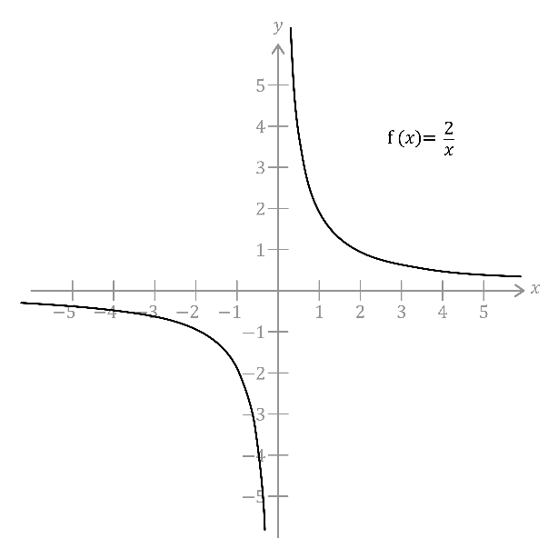
In traditional models (like those using Cagan money demand), plotting seigniorage against inflation yields a "Laffer Curve" that peaks at a specific inflation rate.
However, because of the functional form of utility you used, taking the limit as inflation goes to infinity yields:
$$\lim_{π→∞}{\frac{s}{y}}=\frac{\left(1-δ\right)b}{m}$$
This means that in this specific model, seigniorage asymptotically approaches a maximum limit rather than peaking and falling. The tax base (real money balances) shrinks as inflation rises, but not fast enough to completely offset the higher inflation tax rate.
$$π$$
$$\frac{s}{y}$$

